**USER LOGIN TESTING**

Contents

Empty values provided 2

Invalid credentials provided 3

Invalid password 3

Invalid email provided 4

Valid credentials provided by CLIENT results in 5

Valid credentials provided by TRAINER results in 6

Valid credentials provided by ADMIN results in 7

# Empty values provided

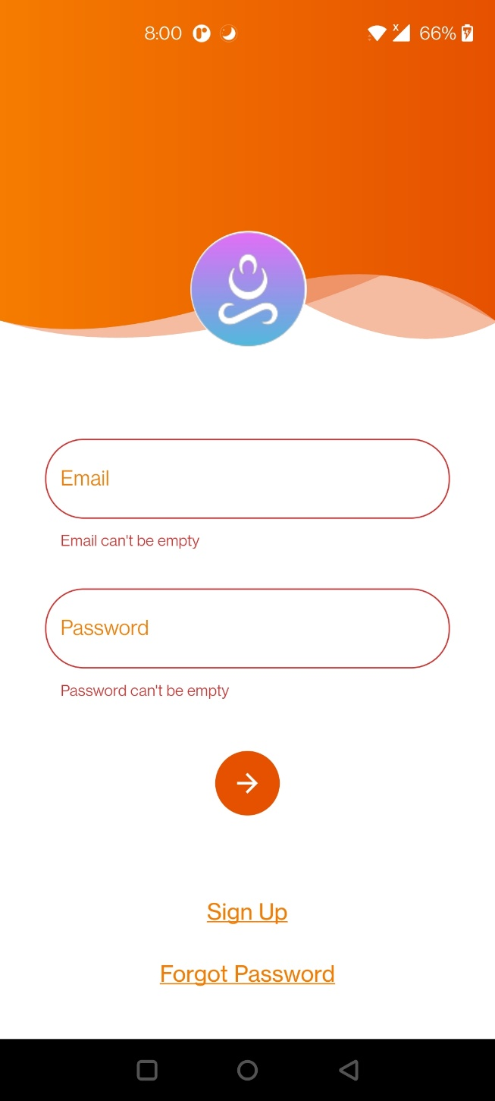

# Invalid credentials provided

## Invalid password

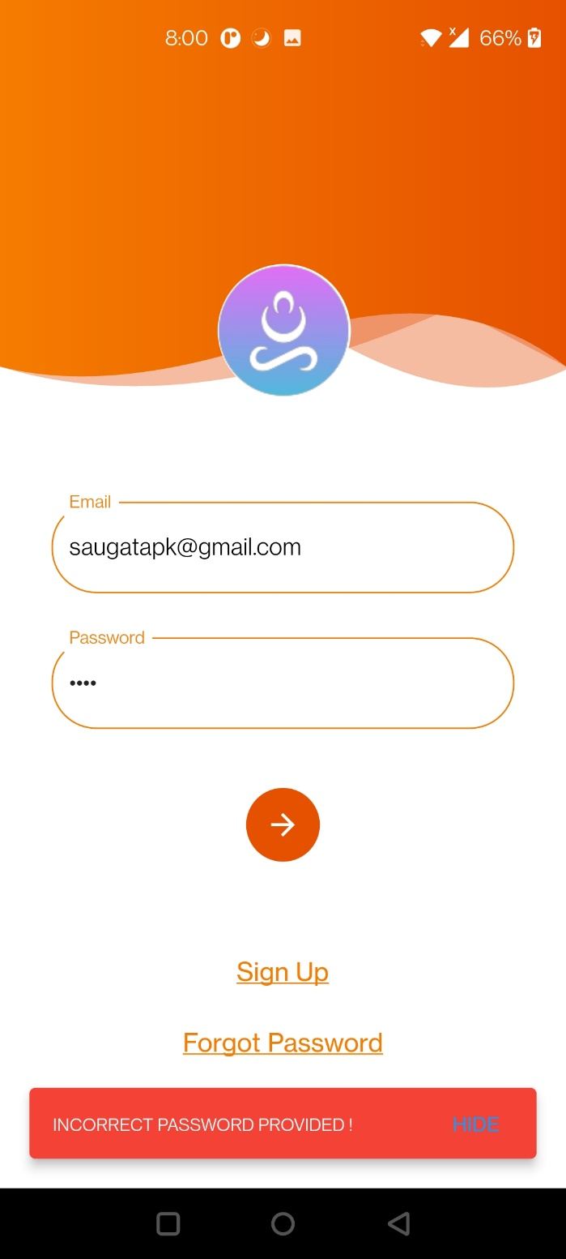

## Invalid email provided

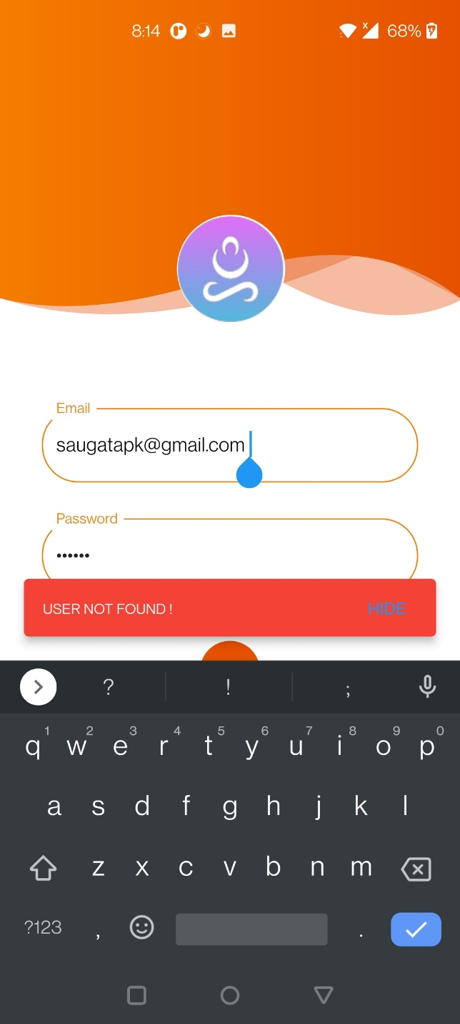

# Valid credentials provided by CLIENT results in



# Valid credentials provided by TRAINER results in



# Valid credentials provided by ADMIN results in

